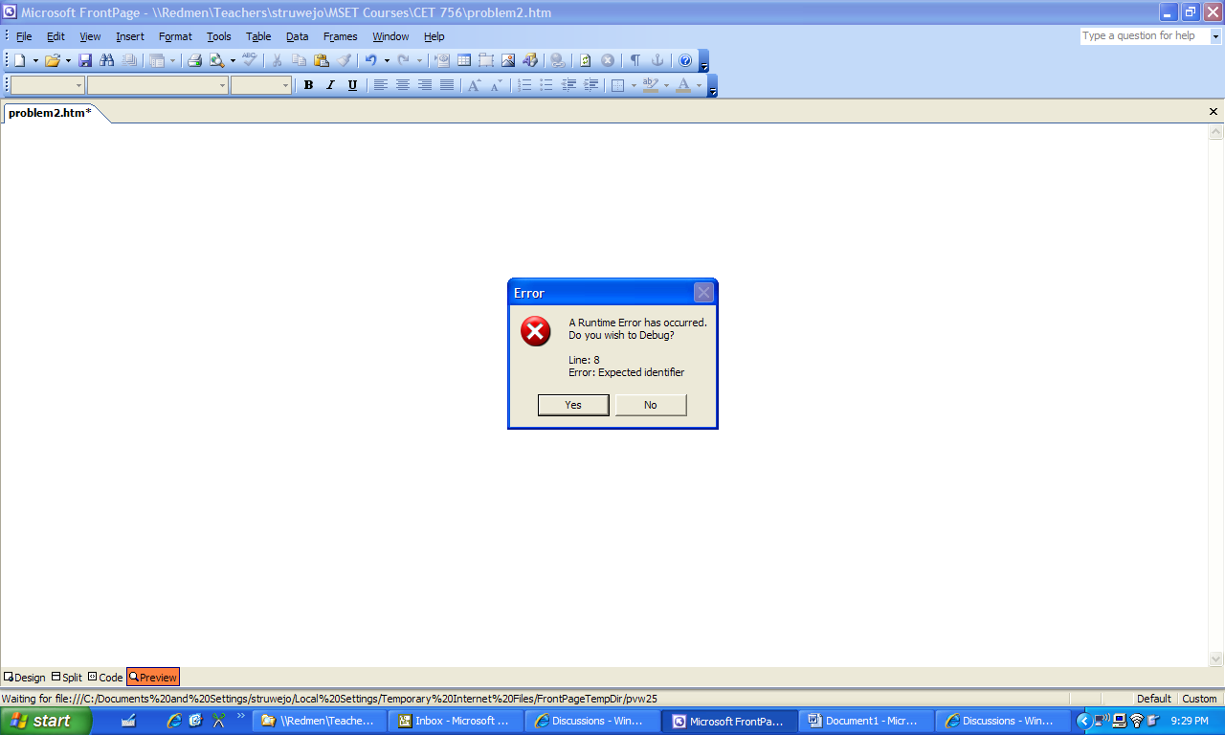
I got this error. I had to add a +” to line 7 to get it to work.

