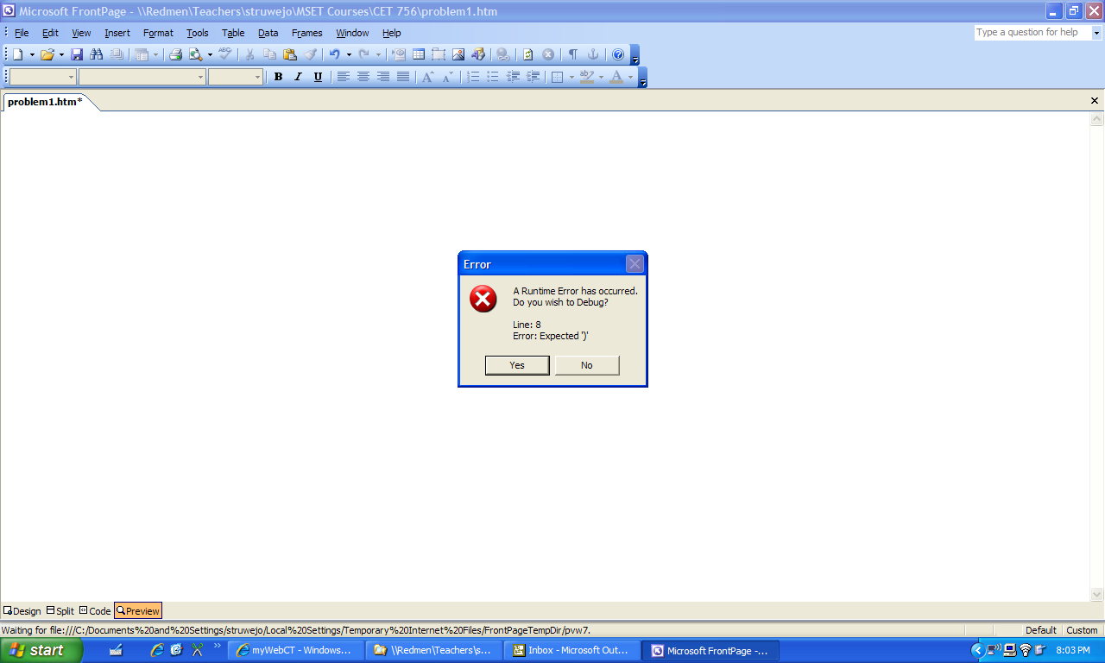
I got this message so I added a ) to the right of …is my favorite team too."

That got me this screen.
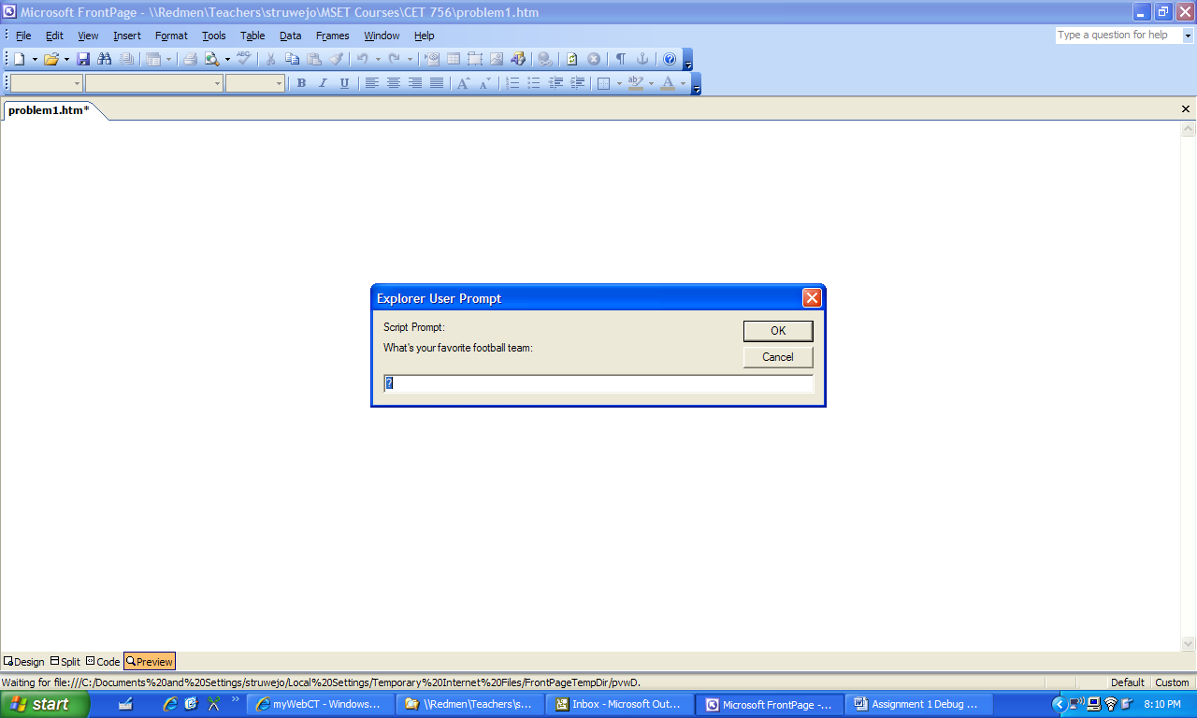

When I entered my team, I got this screen
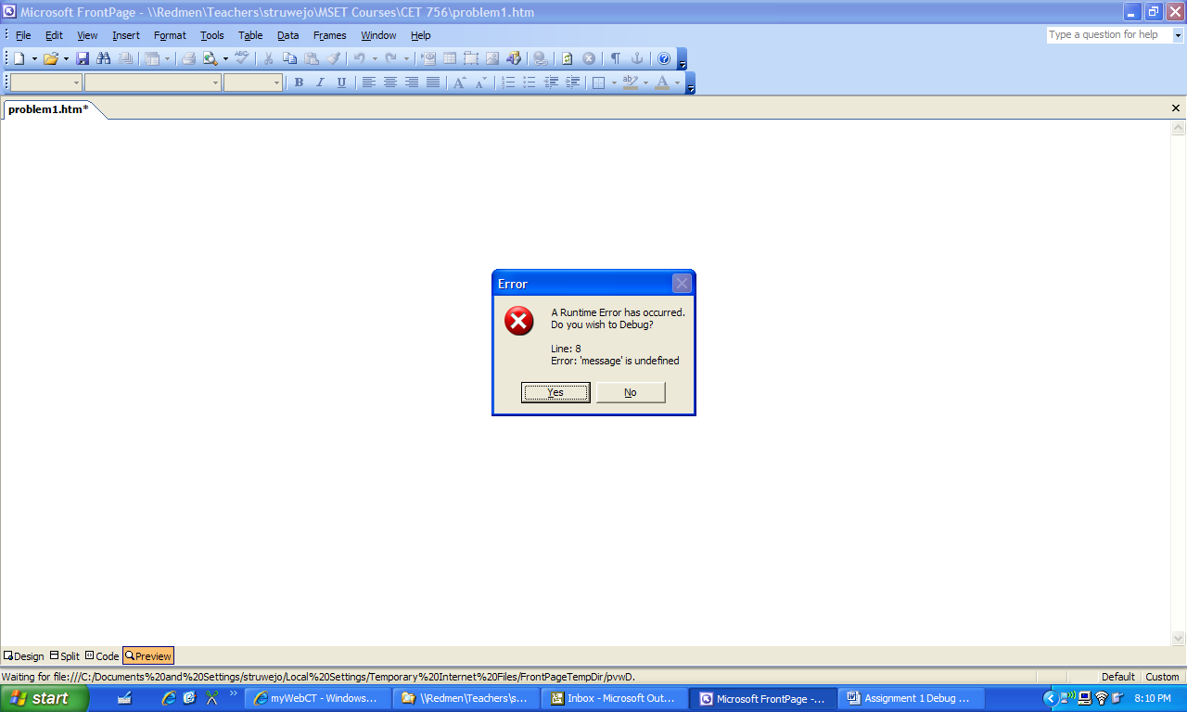

I then found the spelling error in Messsage and correcting that allowed the script to run properly.

